Tela de Consulta de Cliente

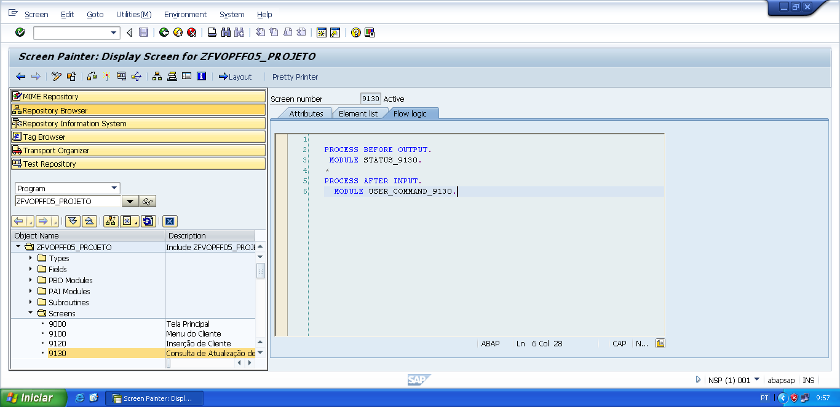

PROCESS BEFORE OUTPUT.  
 MODULE STATUS_9130.

*&---------------------------------------------------------------------*  
*&      Module  STATUS_9130  OUTPUT  
*&---------------------------------------------------------------------*  
*       text  
*----------------------------------------------------------------------*  
MODULE status_9130 OUTPUT.  
  SET PF-STATUS 'STATUS9130'.  
  SET TITLEBAR 'TITULO9130'.  
  
ENDMODULE.                 " STATUS_9130  OUTPUT

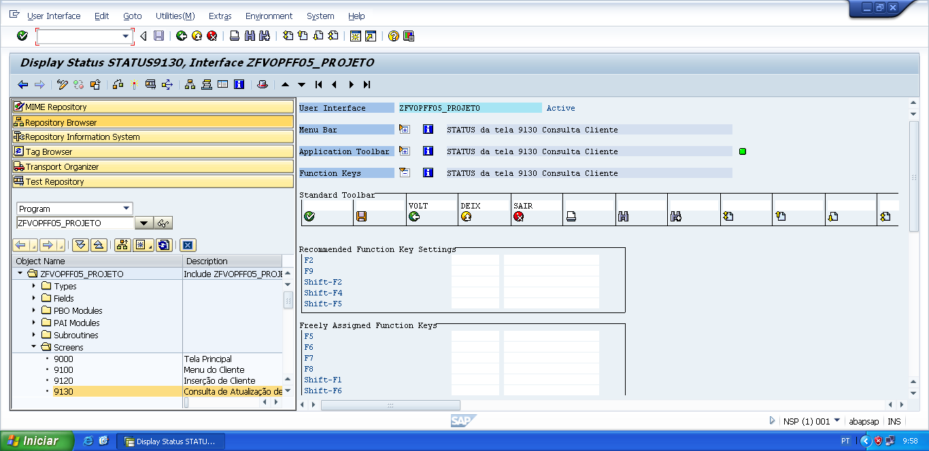

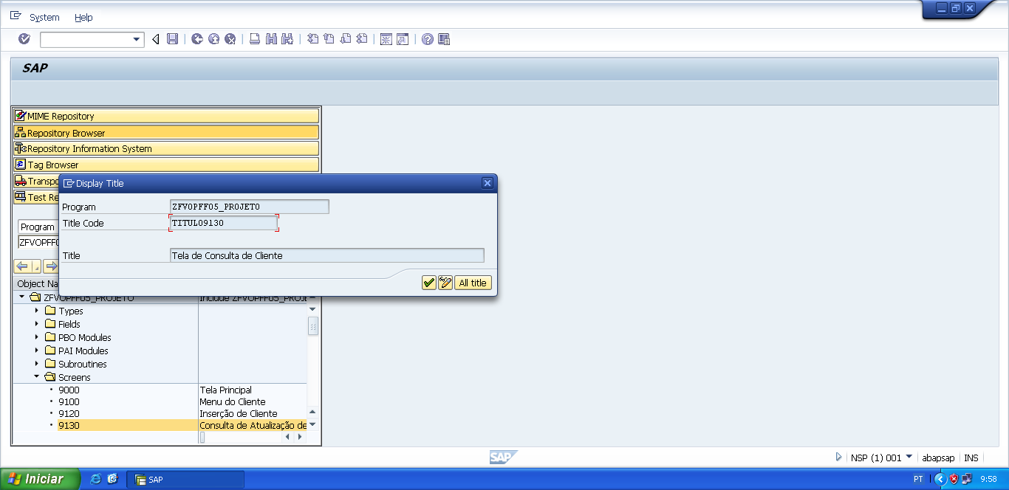

PROCESS AFTER INPUT.  
  MODULE USER_COMMAND_9130.

*&---------------------------------------------------------------------*  
*&      Module  USER_COMMAND_9130  INPUT  
*&---------------------------------------------------------------------*  
*       text  
*----------------------------------------------------------------------*  
MODULE user_command_9130 INPUT.  
  
  v_okcode = sy-ucomm.  
*Casos de status-gui.  
  CASE v_okcode.  
    WHEN 'VOLT'.  
      PERFORM f_voltar.  
    WHEN 'DEIX'.  
      PERFORM f_deixar.  
    WHEN 'SAIR'.  
      PERFORM f_sair.  
  
*Casos de Botões  
    WHEN 'CCL1'.  
      IF v_acao_tela = 'A'.  
        PERFORM f_consulta_cliente USING '9140'.  
      ELSEIF v_acao_tela = 'E'.  
        PERFORM f_consulta_cliente USING '9160'.  
      ELSEIF v_acao_tela = 'D'.  
        PERFORM f_consulta_cliente USING '9190'.  
      ENDIF.  
  ENDCASE.  
  
  CLEAR v_okcode.  
ENDMODULE.                 " USER_COMMAND_9130  INPUT

*&---------------------------------------------------------------------*  
*&      Form  F_VOLTAR  
*&---------------------------------------------------------------------*  
* FORM de voltar, serve para voltar automaticamente para a tela  
*anterior da tela atual.  
*----------------------------------------------------------------------*  
*  -->  p1        text  
*  <--  p2        text  
*----------------------------------------------------------------------*  
FORM f_voltar.  
  
*Volte para á tela 9000 (Tela Principal)  
*ou  
**CALL SCREEN '9000'.**  
  PERFORM f_limpar_variaveis.  
  SET SCREEN 0.  
  LEAVE SCREEN.  
  
  
ENDFORM.                    " F_VOLTAR  
  
*&---------------------------------------------------------------------*  
*&      Form  F_DEIXAR  
*&---------------------------------------------------------------------*  
*       text  
*----------------------------------------------------------------------*  
*  -->  p1        text  
*  <--  p2        text  
*----------------------------------------------------------------------*  
FORM f_deixar .  
  
  LEAVE LIST-PROCESSING.  
  
ENDFORM.                    " F_DEIXAR  
  
*&---------------------------------------------------------------------*  
*&      Form  F_SAIR  
*&---------------------------------------------------------------------*  
*       text  
*----------------------------------------------------------------------*  
*  -->  p1        text  
*  <--  p2        text  
*----------------------------------------------------------------------*  
FORM f_sair.  
  
  LEAVE LIST-PROCESSING.  
  
ENDFORM.                    " F_SAIR

*&---------------------------------------------------------------------*  
*&      Form  F_CONSULTA_CLIENTE  
*&---------------------------------------------------------------------*  
*       text  
*----------------------------------------------------------------------*  
*  -->  p1        text  
*  <--  p2        text  
*----------------------------------------------------------------------*  
FORM f_consulta_cliente USING p_tela TYPE sy-dynnr.  
  
  SELECT  SINGLE cpf_cliente  
                 nome_cliente  
                 end_cliente  
                 tel01_cliente  
                 tel02_cliente  
     FROM zfvtpff05_client  
     INTO wa_zfvtpff05_client  
     WHERE cpf_cliente = v_cpf_cli.  
  
  IF sy-subrc IS INITIAL.  
  
    CALL SCREEN p_tela.  
  
  ELSE.  
  
    MESSAGE s006(zfvclpff05) WITH v_cpf_cli DISPLAY LIKE 'E'.  
  ENDIF.  
  
ENDFORM.                    " F_CONSULTA_CLIENTE

